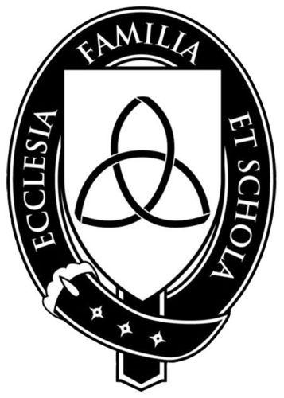

Veritas Academy
2nd Grade Reading List

2013-2014

History Course - Kings and Queens: This course gives an overview of seven of western history’s most illustrious kings and queens in order to acquaint students with the events and achievements of the periods they represent and to see how God has sovereignly worked through them. The reigns of Tutankhamen, Alexander the Great, Caesar Augustus, Alfred the Great, Queen Elizabeth, Louis XIV and Queen Victoria will be the focus of the course.

Veritas has varying numbers of each book available for borrowing (one to two books at a time). Check with the teacher for availability once the term begins. It is the responsibility of parents to obtain the books, from Veritas if available, or from local bookstores, public libraries or Internet sites. Here are some sources for ordering books. The book codes are given for those who wish to order through Sonlight Curriculum.
- Sonlight Curriculum: www.sonlight.com.
- www.amazon.com.
- Barnes and Noble Online: www.bn.com
- Used book stores or Internet sites (e.g. www.abebooks.com)

Read-Alouds (Choose 18 books. Parents read to your student.)

A Child’s Garden of Verses by Robert Louis Stevenson - SL #2A01
*Tut’s Mummy Lost and Found by Judy Donnelly – SL #1H02 or VP #490-870
*The Trojan Horse by Emily Little – VP #490-865
*Alexander the Great by Robert Green – VP #240-010
Mrs. Piggle-Wiggle by Betty McDonald – SL #1A22
*Twice Freed by Patricia St. John – VP #305-557
*Castle Diary by Richard Platt – SL #2A28
*Tales of Robin Hood by T. Allan – SL #2A30
Kildee House by Rutherford Montgomery – SL #1A18
*Good Queen Bess by Diane Stanley and Peter Vennema– SL #2H27
*The Apprentice by Pillar Llorente – SL #2A19
*The Little Lame Prince by Dinah Maria Craik (aka Miss. Mulock) – (Amazon.com)
The Lion, the Witch, and the Wardrobe by C. S. Lewis – VP #255-450
*Heidi (condensed version) by Johanna Spyri – SL #1A02 (Another version is also acceptable.)
Farmer Boy by Laura Ingalls Wilder – (Amazon.com)
The Apple and the Arrow by Mary and Conrad Buff (Amazon.com)
Beezus and Romona by Beverly Clearly (Amazon.com)
Ginger Pye by Eleanor Estes – SL #2A14
The Family Under the Bridge by Natalie Savage Carlson (Amazon.com) (alternate)
The Whipping Boy by Sid Fleischman (Amazon.com) (alternate)
Minstrel in the Tower by Gloria Skurzinsky – SL #2A32 (alternate)

*These books correspond to Kings and Queens specifically

Readers (read by student himself)

Note: At the beginning of the school year, each student will be given a “Reader Summary Folder” with 17 summary forms (excluding the one for The Beginner’s Bible) to be completed as the student reads each book according to a Reader Calendar, which will also be given at the beginning of school.

The Beginner’s Bible – retold by Karyn Henley – SL #2R17
Owl at Home by Arnold Lobel – SL #2R04
The Fire Cat by Esther Averill – SL #2R20
Surprises by Lee Hopkins – SL #2R24
Frog and Toad All Year by Arnold Lobel – SL #2R22
Amelia Bedelia by Peggy Parish – SL #2R23
Nate the Great by Marjorie Sharmat – SL #2R19
Pompeii: Buried Alive by Edith Kunhardt - SL #2R11
Frog and Toad are Friends by Arnold Lobel – SL #2R02
Daniel’s Duck by Clyde Bulla - SL #2R18
Mouse Tales by Arnold Lobel – SL #2R16
The Big Balloon Race by Eleanor Coerr – SL #2R15
Wagon Wheels by Barbara Brenner – SL #2R14
Hill of Fire by Thomas Lewis –SL #2R09
Frog and Toad Together by Arnold Lobel – SL #2R03
Titanic Lost and Found by Judy Donnelly – SL #2R12
Greg’s Microscope by Millicent Selsam - #2R21
The Sword in the Tree by Clyde Bulla – SL #2R27

Literature Units (provided by Veritas Academy and studied in class)
Poetry Unit

Miss Nelson is Missing by James Marshall
Ox-Cart Man by Donald Hall
Paul Bunyan (and other Kellogg tall tales) by Steven Kellogg
The Velveteen Rabbit by Margery Williams
A Chair for My Mother by Vera B. Williams
The Emperor’s New Clothes (and other fairy tales) by Hans Christian Andersen
Doctor DeSoto by William Steig
Ralph S. Mouse by Beverly Cleary

